A1356-ME-Mesopotamia-Lagash-Foundation Cone-Gudea-2144 - 2124 BCE

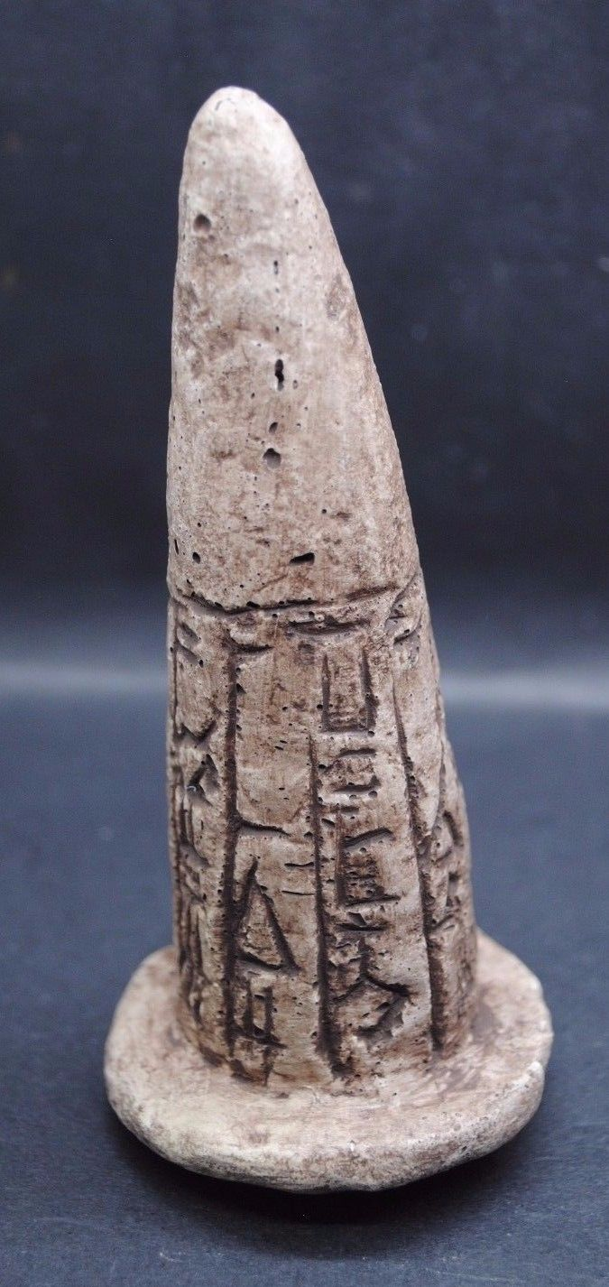 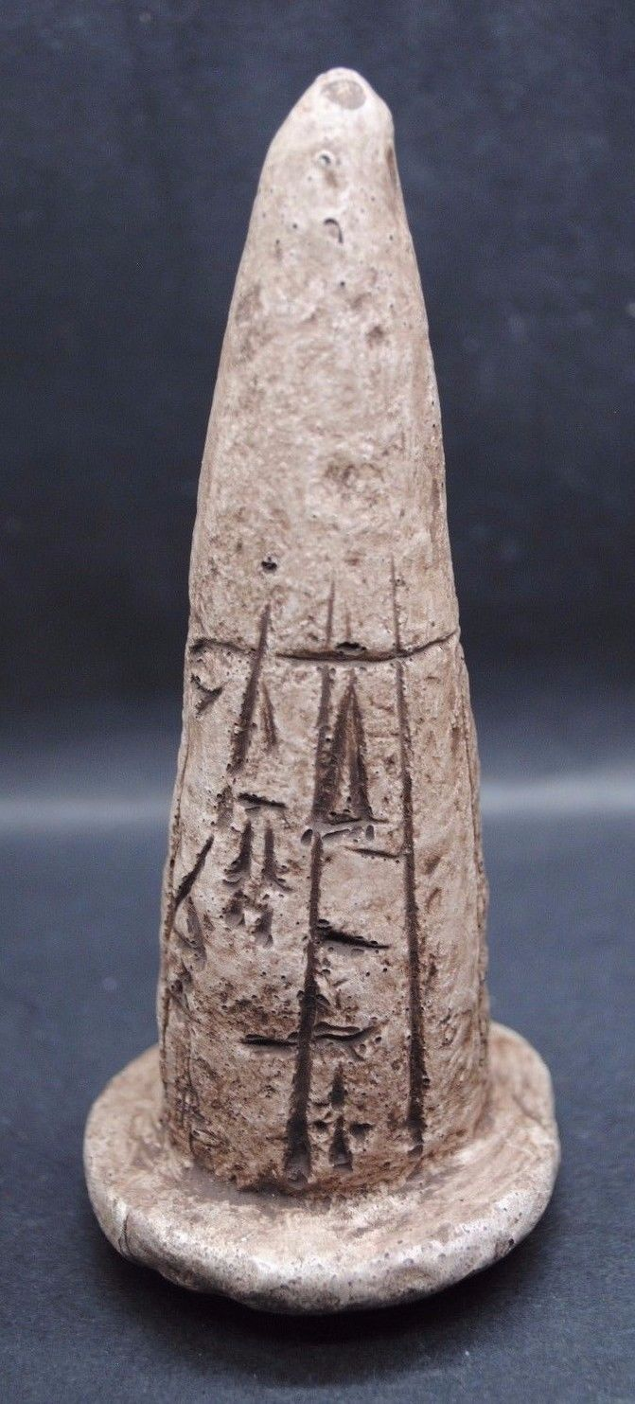

Figs. 1-2. Mesopotamia-Lagash-Foundation Cone-Gudea-2144 - 2124 BCE

**Case no.: 2**

**Accession Number: A000**

**Formal Label:** Mesopotamia-Lagash-Foundation Cone-Gudea-2144 - 2124 BCE

**Display Description:**

Foundation cones like this were placed in the interior temple walls of ancient Sumer to record information about the ruler who erected the edifice and information about the temple and the deity to which it was dedicated. The exposed ends of these cones were occasionally dipped in bright colors and set as mosaic patterns in the walls of the foundation. “Gudea built and restored the Eninnu temple, for god Ningirsu, his lord.” Gudea was ruler or “ensi” of the state of Lagash in southern Mesopotamia who ruled ca 2144 - 2124 BCE.

**LC Classification: PJ4013**

**Date or Time Horizon:** 2144 - 2124 BCE

**Geographical Area:** Mesopotamia-Lagash

**Map:**

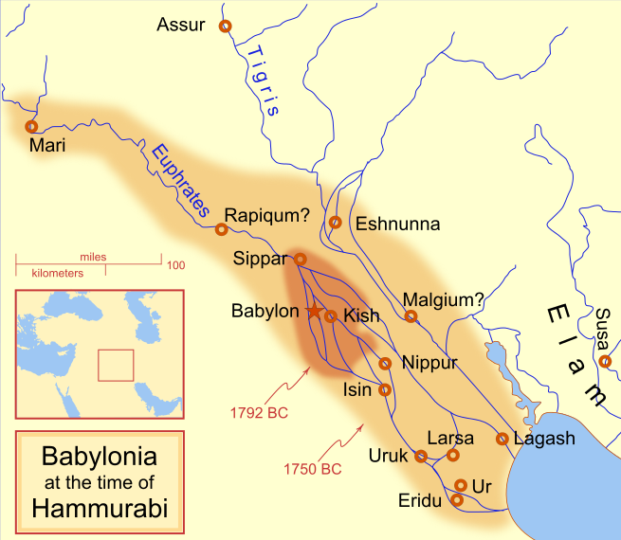

A locator map of Hammurabi's Babylonia, showing the Babylonian territory upon his ascension in 1792 BC and upon his death in 1750 BC. The river courses and coastline are those of that time period -- in general, they are not the modern rivers or coastlines. This is a Mercator projection, with north in its usual position. There is some question to what degree the cities of Nineveh, Tuttul, and Assur were under Babylonian authority. While in his introduction to his code of laws, Hammurabi claims lordship over these cities, Roaf does not include any of these in his map, upon which this map is based, and Chevalas states that "Assur and Nineveh were held for a very few years" (p. 155). Therefore, I have not included them as under Hammurabi's control in 1750 BC. 18 February 2008, Own work, [MapMaster](https://commons.wikimedia.org/wiki/User:MapMaster)

**GPS coordinates:** [31°24′41″N 46°24′26″E](https://tools.wmflabs.org/geohack/geohack.php?pagename=Lagash&params=31_24_41_N_46_24_26_E_type:landmark)

**Cultural Affiliation:**

**Media:** Clay

**Dimensions:** 141 x 62.7mm

**Weight:**

**Condition: original**

**Provenance:** old English Collection

**Discussion:**

Gudea probably did not come from the city, but had married Ninalla, daughter of the ruler Urbaba (2164 - 2144 BC) of Lagash, thus gaining entrance to the royal house of Lagash.

**References:**

Bjorklund, Oddvar; Holmboe, Haakon; Rohr, Anders (1970) Historical Atlas of the World, Barnes & Noble, NY, SBN: 389-00253-4.

Chavalas, Mark W.; K. Lawson Younger. 2003. Mesopotamia and the Bible, Continuum International Publishing Group,

Roaf, M. 1990. *Cultural Atlas of Mesopotamia and the ancient Near East*. Oxford: Facts on File.

Van De Mieroop, Marc. 2005. *King Hammurabi of Babylon: A Biography*. London: Blackwell Publishing.

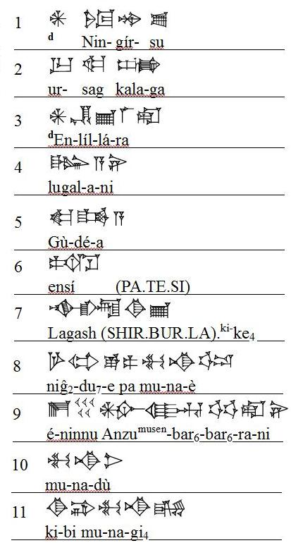

Top photo, middle line:

E2 NINU(same sign as 50)  d.IM

GI6 MUSHEN  UD UD  RA  NI

GI6 is same as MI sign

UD sign has reading bir6 in transliterations)

|  |
| --- |
| http://www.collector-antiquities.com/clear.gif |
| http://www.collector-antiquities.com/uploads/pics/peters_cone_001.JPG |

Second photo, first line:

MU NA DU3 (same as NI sign)

Second line: KI BI  MU NA GI4

http://www.collector-antiquities.com/clear.gif

|  |
| --- |
| http://www.collector-antiquities.com/clear.gif |
| http://www.collector-antiquities.com/uploads/pics/peters_cone_002.JPG |

Below, top main  line you can see the commonly come across...

dingir  nin  gir su

second line is UR SAG KALA GA

last:  d.EN LIL2  LA2 RA

http://www.collector-antiquities.com/clear.gif

|  |
| --- |
| http://www.collector-antiquities.com/clear.gif |
| http://www.collector-antiquities.com/uploads/pics/peters_cone_003.JPG |

Another  dingir  nin  gir su from another  cone.

http://www.collector-antiquities.com/clear.gif

|  |
| --- |
| http://www.collector-antiquities.com/clear.gif |
| http://www.collector-antiquities.com/uploads/pics/Gudea_cone_1_01.jpg |

And the  very frequently found  name, Gudea......

GU DE A

http://www.collector-antiquities.com/clear.gif

|  |
| --- |
| http://www.collector-antiquities.com/clear.gif |
| http://www.collector-antiquities.com/uploads/pics/peters_cone_004.JPG |

Another two examples of

GU DE A

http://www.collector-antiquities.com/clear.gif

|  |  |  |
| --- | --- | --- |
| http://www.collector-antiquities.com/clear.gif | | |
| http://www.collector-antiquities.com/typo3temp/pics/a8039d3121.jpg | http://www.collector-antiquities.com/clear.gif | http://www.collector-antiquities.com/typo3temp/pics/c447880906.jpg |

first line:

PA.TE.SI (althree signs together are read as ensi2 = governor)

next line: SIR2.BUR.LA.KI  is logogram for Lagasha  last sign is KE4 genetive marker

http://www.collector-antiquities.com/clear.gif

|  |
| --- |
| http://www.collector-antiquities.com/clear.gif |
| http://www.collector-antiquities.com/uploads/pics/peters_cone_005.JPG |

top:

NIG2 DU6 E PA MU

                          NA E3

http://www.collector-antiquities.com/clear.gif

|  |
| --- |
| http://www.collector-antiquities.com/clear.gif |
| http://www.collector-antiquities.com/uploads/pics/peters_cone_006.JPG |

In his numerous inscriptions Gudea, governor of the city-state Lagash, related the many pious building projects he carried out and dedicated to the divinities of the city.  The building of the Eninnu, the temple of Ningirsu, seems to have been the great project of his reign.  Two hymns, each written on a large clay cylinder, recount different stages of its construction.